UMBC LIFE SIM 2020 - QUARANTINE EDITION  
Campus life has never been so lonely

A game produced by BOHN  
Mark Nay, Richard Ho, Sriram Batchu, David Onwonga

*COMP 101Y, Fall 2020*

**DESIGN DELIVERABLE**

**Part 1: Architecture**

**Figure 1**. High-level diagram of major functions (represented by boxes) and function calls (represented by arrows).

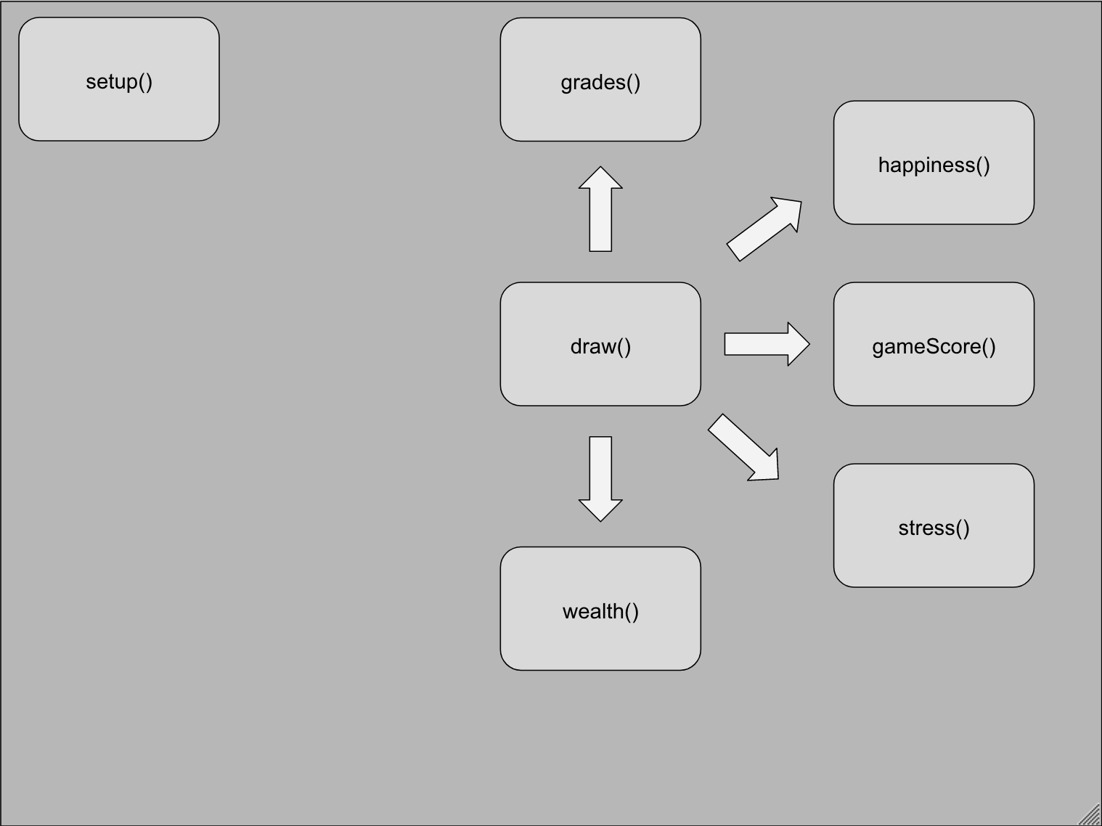

The setup() function doesn’t use any other functions inside of its function.

The draw() loop uses grades(), happiness(), gameScore(), stress, and likely most other functions that may be created.

**Major Functions:**

* void setup ()
  + create the display window
    - * 1200x1000
  + Load images of UMBC campus buildings, dorms, etc.
  + Error checking (checks for range of variables)
* void draw ()
  + Calls functions
* void gameScore()
  + Processes game score
  + Shows game score
  + Average of stress, happiness, wealth, and grades
* void wealth()
  + Processes wealth score
  + # of hours worked goes here
    - More hours worked = more wealth
* void stress()
  + Processes stress score
  + Number of credits
  + Hours spent on solitary leisure activities
  + Hours spent on activities with other people
* void happiness()
  + Processes happiness score
  + % of class actively engaged
  + Hours spent attending class
  + Hours spent studying
  + Hours spent taking care of self
  + Hours spent on solitary leisure activities
  + Hours spent on activities with other people
* void grades()
  + Processes grade score
  + % of class actively engaged
  + Hours spent attending class
  + Hours spent studying
  + Hours spent in studying groups
  + Hours spent in academic resources
  + Hours spent taking care of self

**Part 2: Data**

Global variables:

final int numOfCredits // number of credits chosen

int gradeScore // score of grades

int wealthScore //score of wealth

int stressScore //score of stress

int happinessScore //score of happiness

int totalGameScore //total game score average

int workHours //number of credits being taken

int hoursWorked //number of hours worked/week

int solitaryActivity //hours spent on solitary activity

int groupActivity //hours spent on group activities

int timeInClass //hours spent attending class

int timeStudying //hours spent studying

int selfCare //hours spent doing self care

int studyGroup //hours spent in study groups

int academicResources //hours spent using academic resources

Use pimage variable

**Part 3: Look and Feel**

**Input**: The input box will appear for the player to input a number for the given range of a variable (number of credits, time spent studying, etc.).

**Output**: The final layout should look like this (for numofCredits = 21, stress increases 25%).

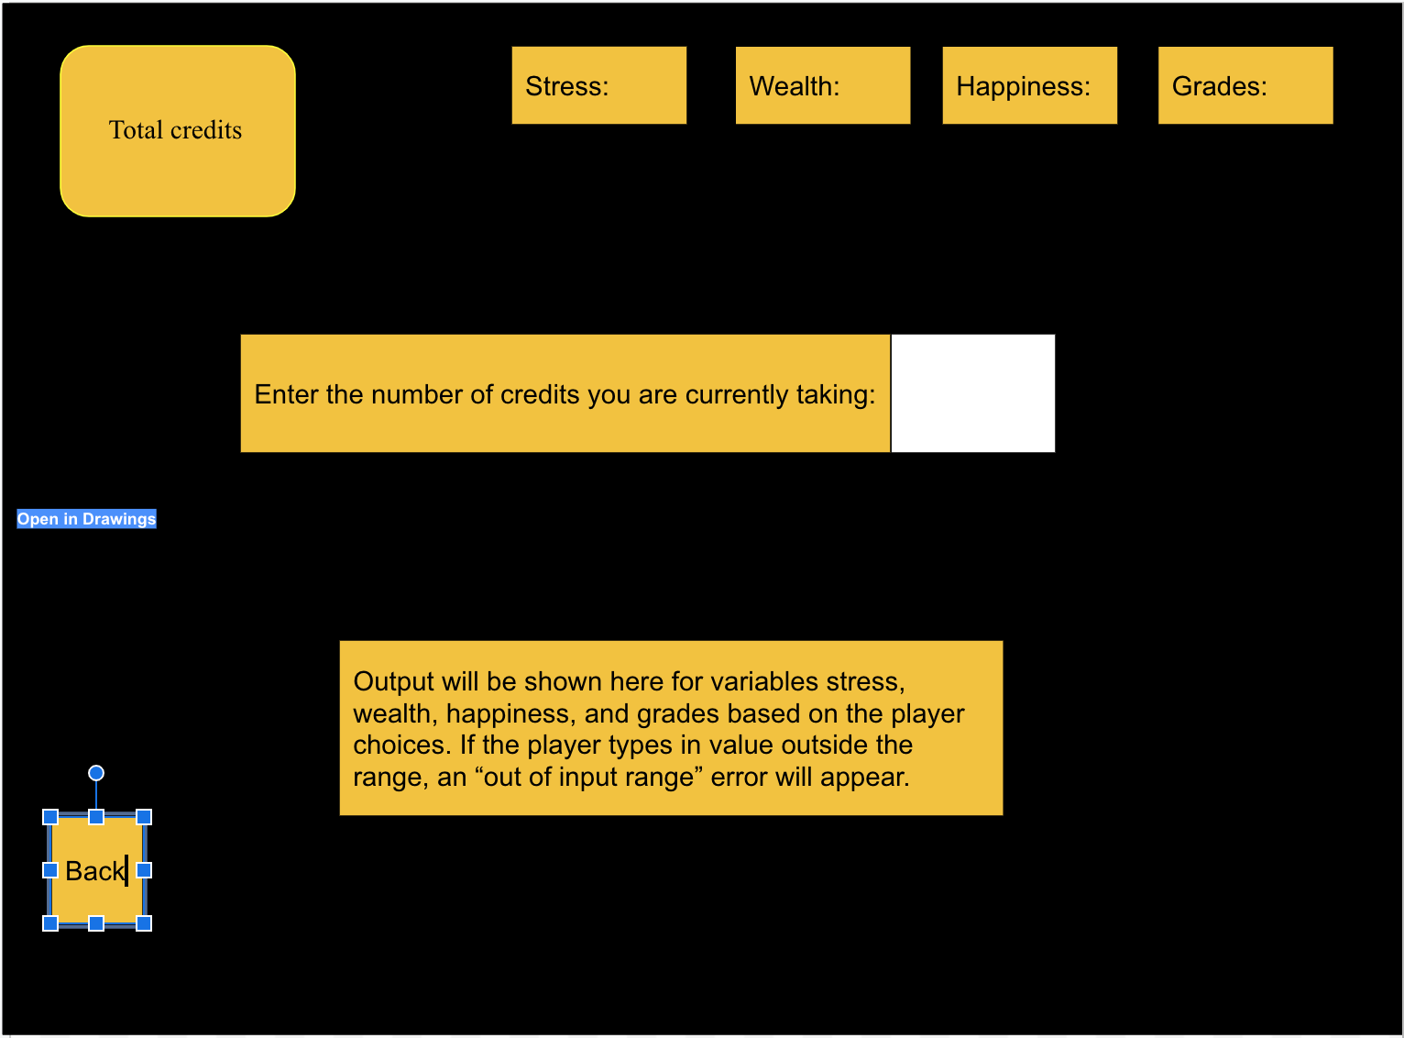

The above picture is a scenario in which the player has to input the number of credits to take for a semester.

The stress, wealth, happiness, and grades boxes will be permanently displayed on screen and show the respective scores.The back button will be constant, similar to how the Android operating system back button functions.. The other boxes’ inputs will change based on player input and game output.

In this example, the player would input the number of credits into the white box. After inputting a number, if the number is inside of the given range (0-21 for this example), the box below the input box will show how your decision modifies your variables (e.g. + 5% stress). If the number is outside of the given range (such as 25), an error message will be displayed and the player will need to submit a new number.

**Appendix: Group Contributions**

Mark Nay:

* Functions
  + Void gameScore
  + Void happiness
* Variables
* Descriptions/captions

Sriram Batchu:

* Variable Example drawing
* Functions:
  + Void grades
  + Void setup

Richard Ho:

* Design Architecture drawing
* Functions:
  + Void draw
  + Void wealth

David Onwonga:

* Didn’t make it to first meetings; will probably work on programming with Mark